Steps to integrate with Auth0 –

1. Signup with email or signup with social login first in Auth0 portal.

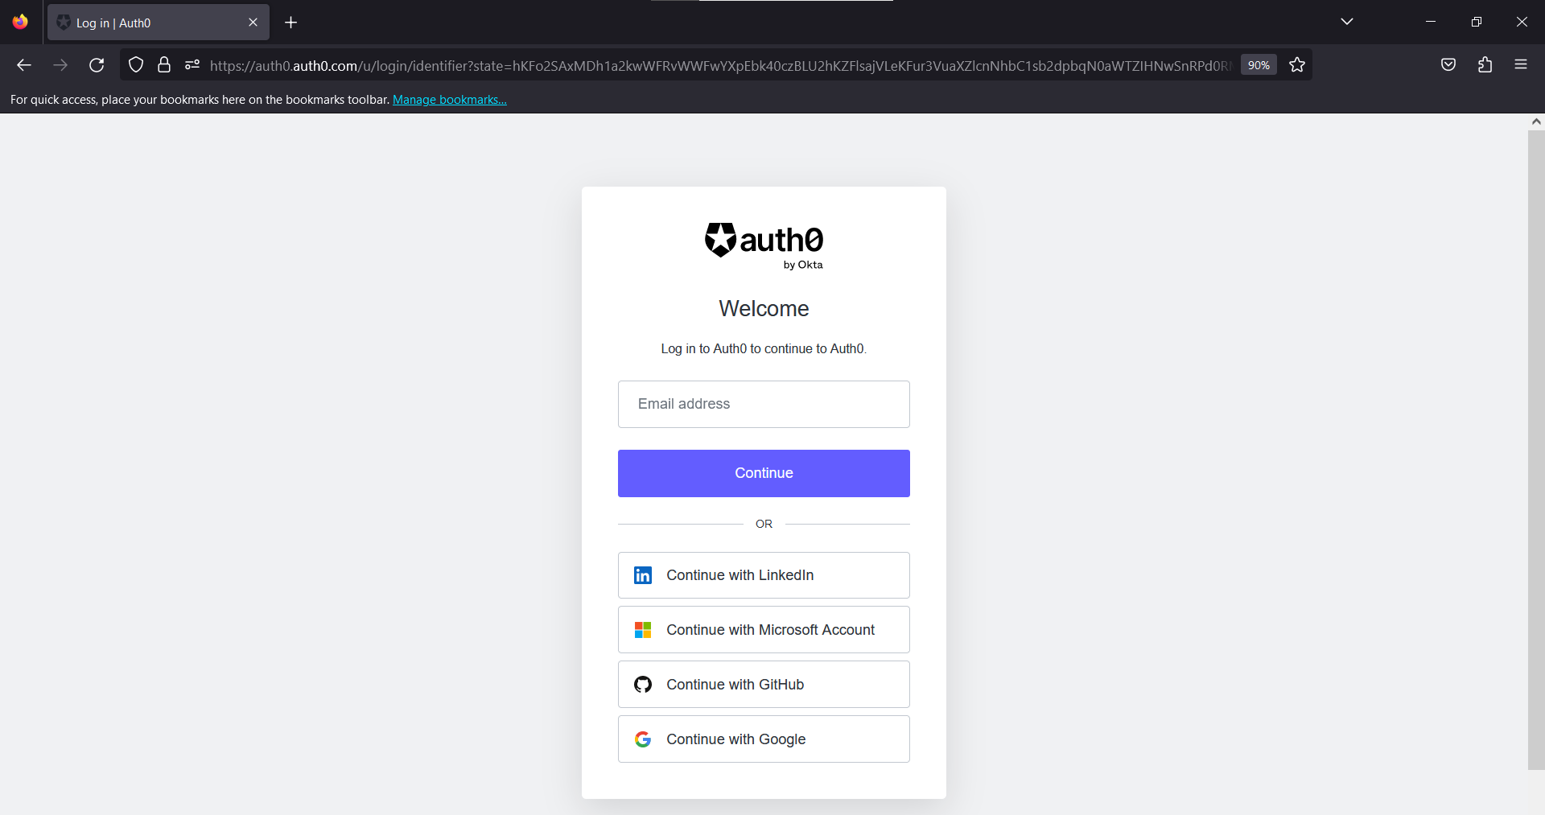

1. Create a tenant
2. Create an application and select Application Type as Regular Web Application

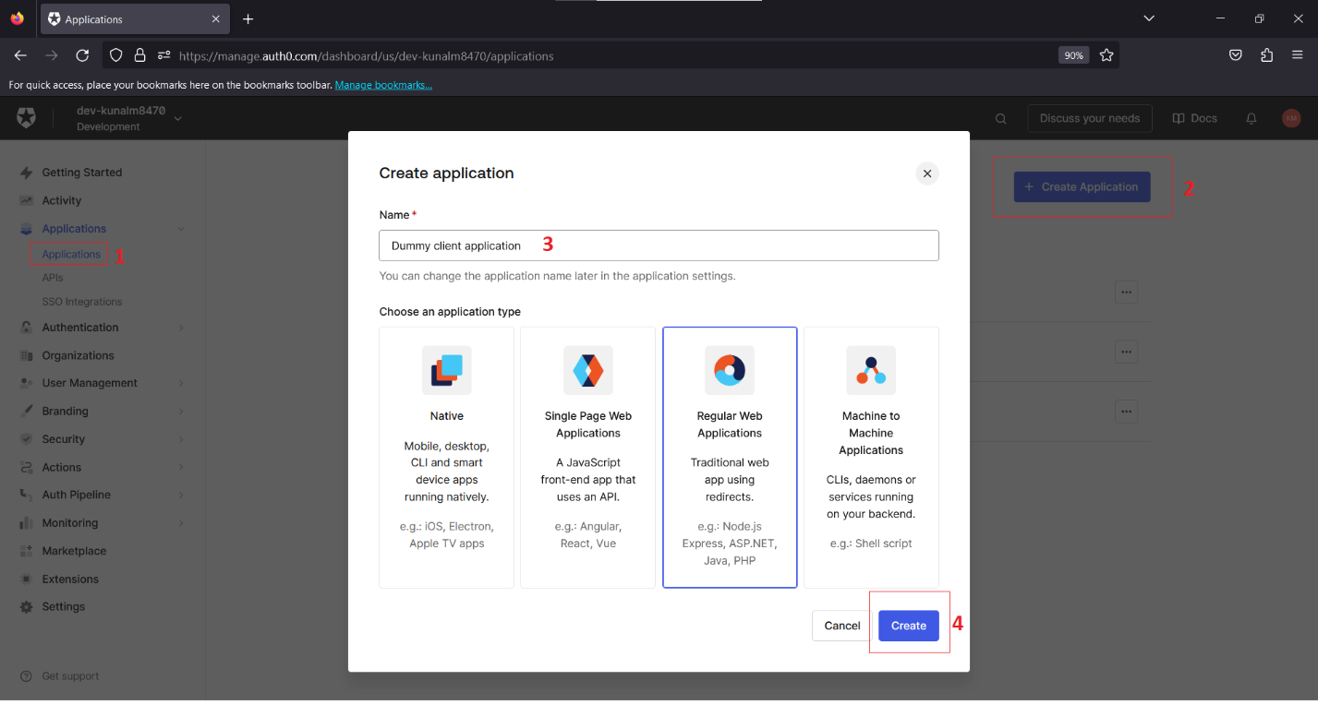

1. Add the following settings in the after creating the application.

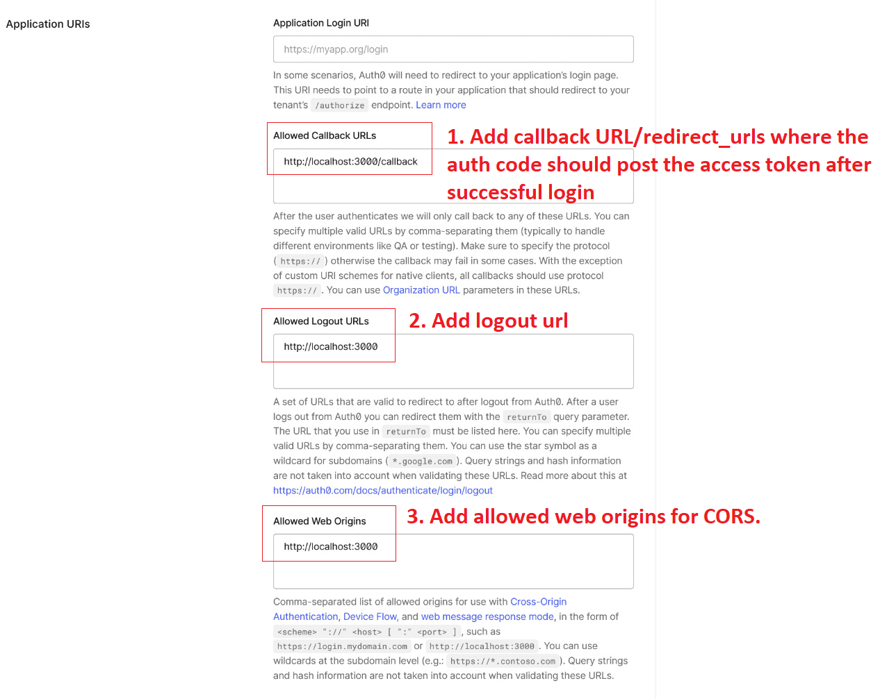

1. Create API and add audience

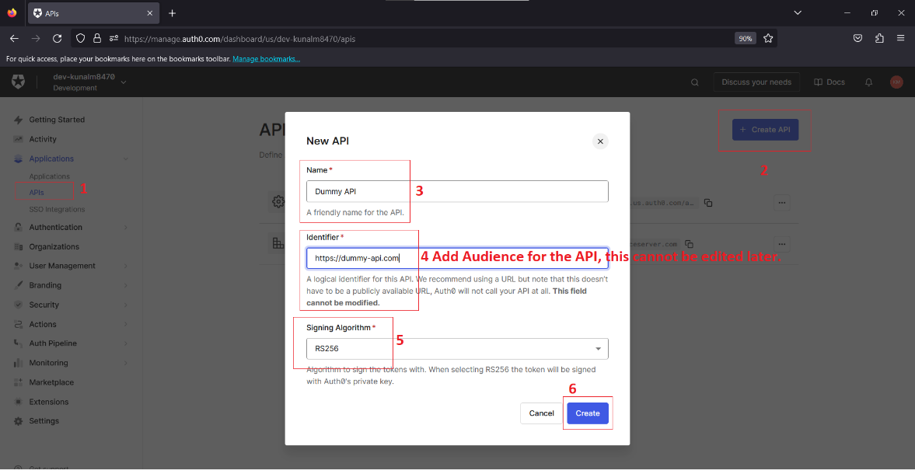

1. Authorize client application to request for access tokens from the API in the API settings

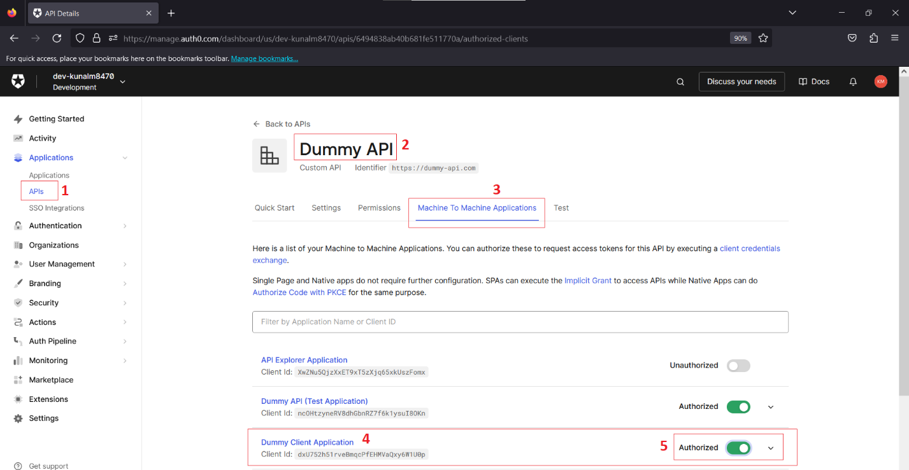

1. Add permissions to the API for making use of custom scopes

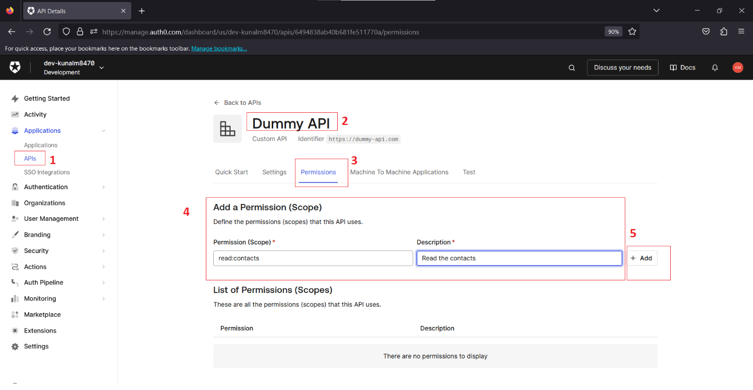

1. Enable RBAC and adding of permission claim in API settings

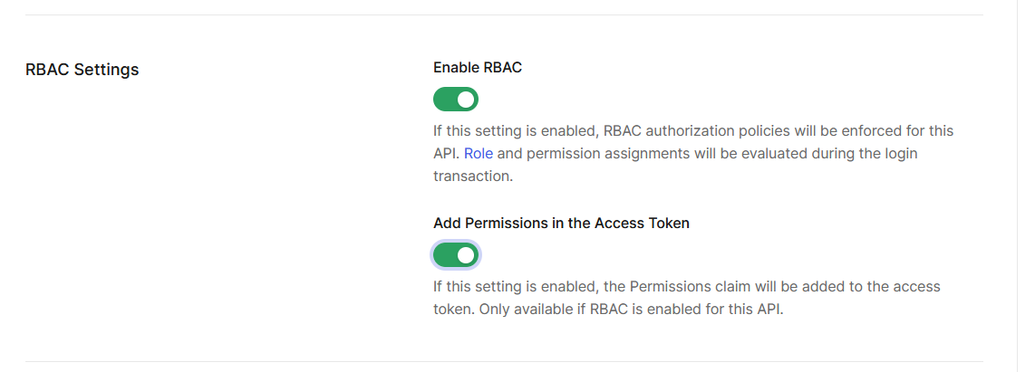

1. Add a user role

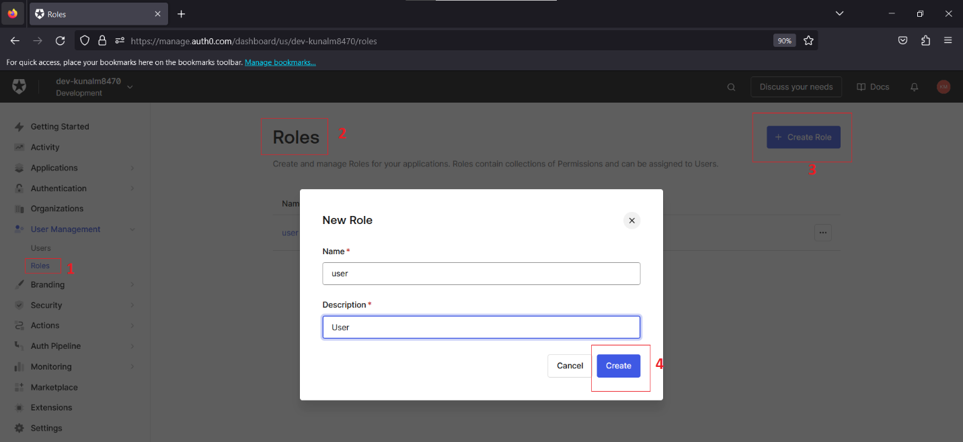

1. Assign permission to “user” role

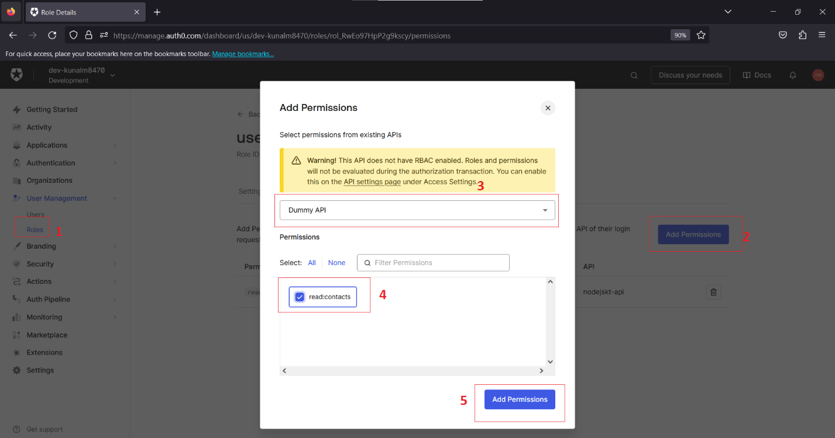

1. Add role to user after signup using Auth0 actions in “post-registration” flow using custom Node.js code attached as a script.

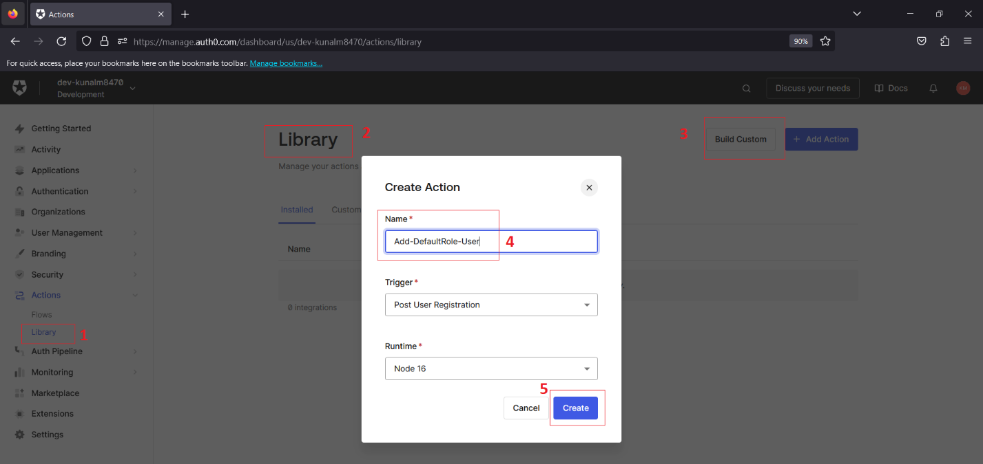

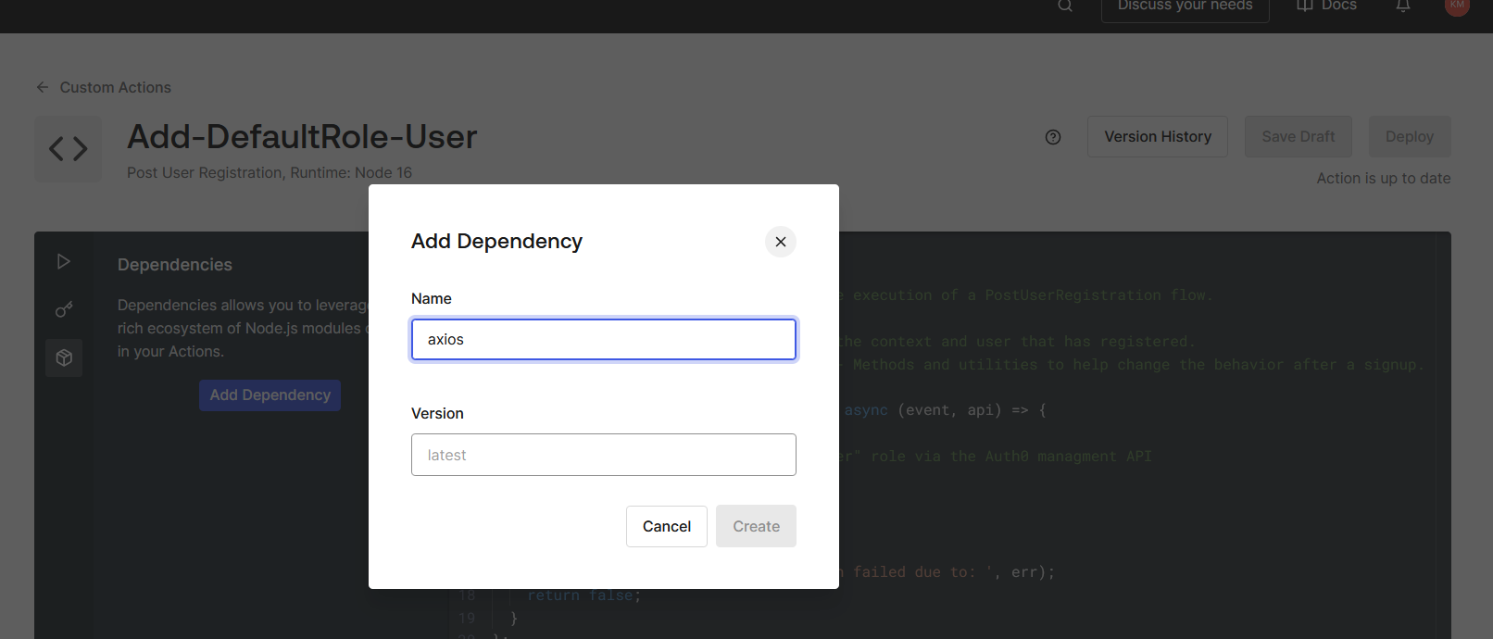

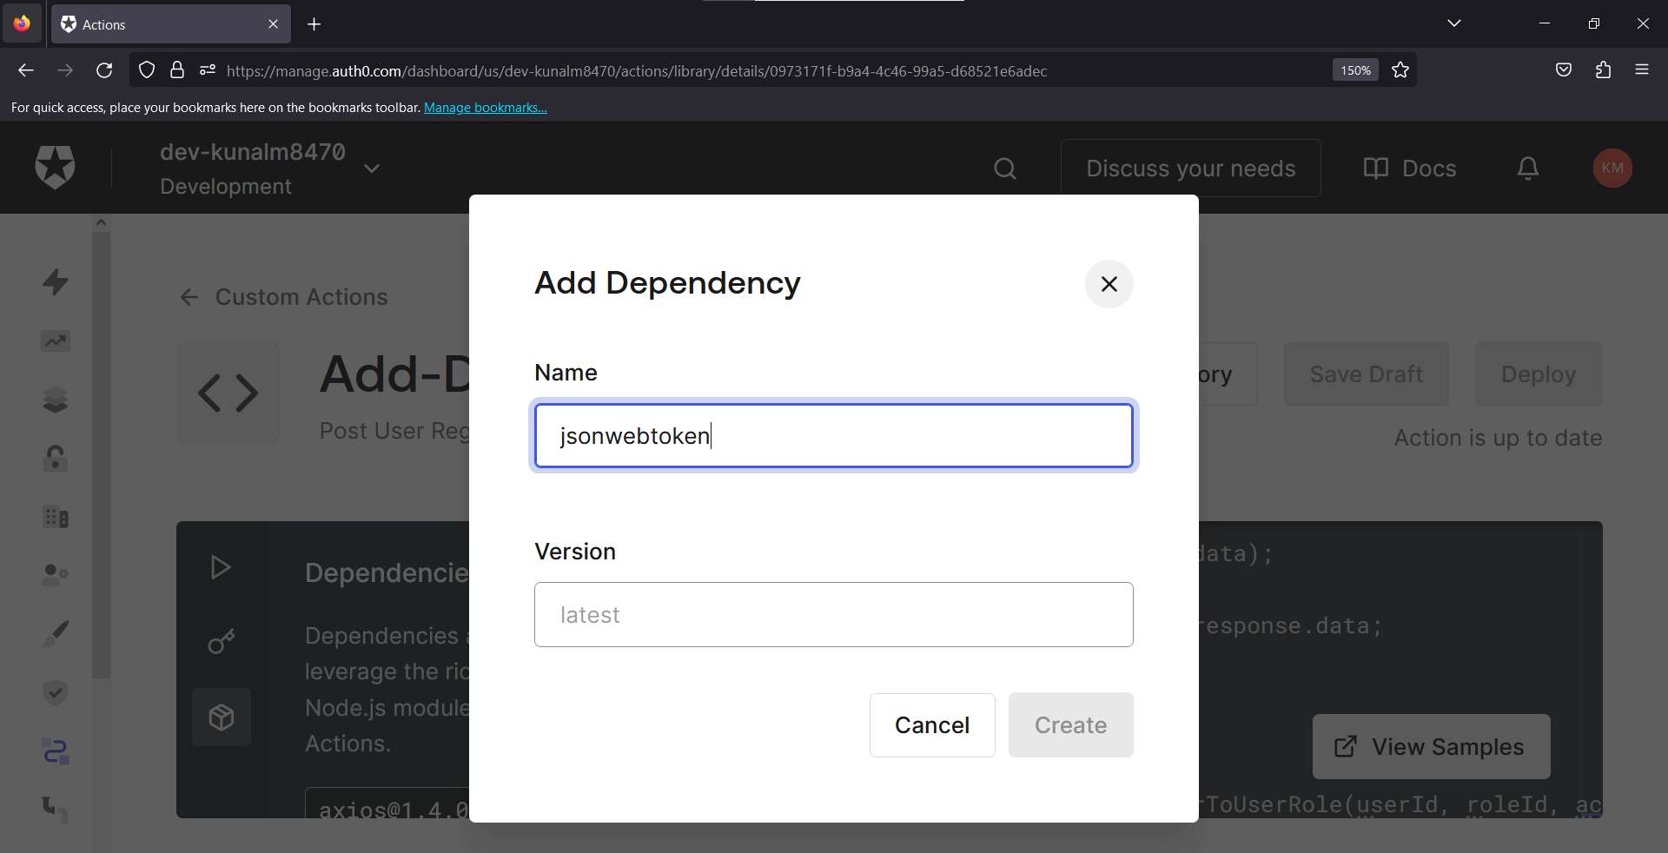

1. Assign Auth0 action before the Post-User-Registration and save.

